Administrative module of caBench-to-Bedside v3.0
Administration Manual

Document Change History
Version Number | Date | Contributor | Description
V1.0 | June 25, 2008 | Washington University/Persistent Systems | Reviewed
V2.1 | December 4, 2008 | Washington University/Persistent Systems | Reviewed
V2.1 | December 23,2008 | Washington University/Persistent Systems | Reviewed by Documentation and Training workspace
V3.0 | June 26, 2009 | Washington University/Persistent Systems | Reviewed
V3.0 | July 25, 2009 | Washington University/Persistent Systems | Addressed comments by Documentation and Training workspace



This is a U.S. Government work. August 11, 2009

Development Team(s)
Development | User’s Guide | Program Management
Chandrakant Talele¹ | Chandrakant Talele¹ | Rakesh Nagarajan²
Srinath Krishnamurthy¹ | Srikanth Adiga¹ | Srikanth Adiga¹
Deepak Shingan¹ | Madhumita Shrikhande¹ | Mukesh Sharma²
Chetan Patil¹ | Madhurima Bhattacharjee¹
Hrishikesh Rajpathak¹ | Pooja Arora¹
Lalit Chand¹ | Mukesh Sharma²
Atul Jawale¹
¹Persistent Systems Limited | ²Washington University

Contacts and Support
Training contact | cab2bsupport@bmi.wustl.edu
Customer support contact | cab2bsupport@bmi.wustl.edu

Copyright and License Information

Copyright Notice. Copyright 2005 “School of Medicine, Washington University in St. Louis” (“caBIG® Participant”). cancer Bench-to-Bedside was created with NCI funding and is part of the caBIG® initiative. The software subject to this notice and license includes both human readable source code form and machine readable, binary, object code form (the “caBIG® Software”).
This caBIG® Software License (the “License”) is between caBIG® Participant and You. “You (or “Your”) shall mean a person or an entity, and all other entities that control, are controlled by, or are under common control with the entity. “Control” for purposes of this definition means (i) the direct or indirect power to cause the direction or management of such entity, whether by contract or otherwise, or (ii) ownership of fifty percent (50%) or more of the outstanding shares, or (iii) beneficial ownership of such entity.
License. Provided that You agree to the conditions described below, caBIG® Participant grants You a non-exclusive, worldwide, perpetual, fully-paid-up, no-charge, irrevocable, transferable and royalty-free right and license in its rights in the caBIG® Software, including any copyright or patent rights therein that may be infringed by the making, using, selling, offering for sale, or importing of caBIG® Software, to (i) use, install, access, operate, execute, reproduce, copy, modify, translate, market, publicly display, publicly perform, and prepare derivative works of the caBIG® Software; (ii) make, have made, use, practice, sell, and offer for sale, and/or otherwise dispose of caBIG® Software (or portions thereof); (iii) distribute and have distributed to and by third parties the caBIG® Software and any modifications and derivative works thereof; and (iv) sublicense the foregoing rights set out in (i), (ii) and (iii) to third parties, including the right to license such rights to further third parties. For sake of clarity, and not by way of limitation, caBIG® Participant shall have no right of accounting or right of payment from You or Your sublicensees for the rights granted under this License. This License is granted at no charge to You. Your downloading, copying, modifying, displaying, distributing or use of caBIG® Software constitutes acceptance of all of the terms and conditions of this Agreement. If you do not agree to such terms and conditions, you have no right to download, copy, modify, display, distribute or use the caBIG® Software.
- Your redistributions of the source code for the caBIG® Software must retain the above copyright notice, this list of conditions and the disclaimer and limitation of liability of Article 6 below. Your redistributions in object code form must reproduce the above copyright notice, this list of conditions and the disclaimer of Article 6 in the documentation and/or other materials provided with the distribution, if any.
- Your end-user documentation included with the redistribution, if any, must include the following acknowledgment: “This product includes software developed by School of Medicine, Washington University in St. Louis.” If You do not include such end-user documentation, You shall include this acknowledgment in the caBIG® Software itself, wherever such third-party acknowledgments normally appear.
- You may not use the names “School of Medicine, Washington University in St. Louis”, “The National Cancer Institute”, “NCI”, “Cancer Bioinformatics Grid” or “caBIG®” to endorse or promote products derived from this caBIG® Software. This License does not authorize You to use any trademarks, service marks, trade names, logos or product names of either caBIG® Participant, NCI or caBIG®, except as required to comply with the terms of this License.
- For sake of clarity, and not by way of limitation, You may incorporate this caBIG® Software into Your proprietary programs and into any third party proprietary programs. However, if You incorporate the caBIG® Software into third party proprietary programs, You agree that You are solely responsible for obtaining any permission from such third parties required to incorporate the caBIG® Software into such third party proprietary programs and for informing Your sublicensees, including without limitation Your end-users, of their obligation to secure any required permissions from such third parties before incorporating the caBIG® Software into such third party proprietary software programs. In the event that You fail to obtain such permissions, You agree to indemnify caBIG® Participant for any claims against caBIG® Participant by such third parties, except to the extent prohibited by law, resulting from Your failure to obtain such permissions.
- For sake of clarity, and not by way of limitation, You may add Your own copyright statement to Your modifications and to the derivative works, and You may provide additional or different license terms and conditions in Your sublicenses of modifications of the caBIG® Software, or any derivative works of the caBIG® Software as a whole, provided Your use, reproduction, and distribution of the Work otherwise complies with the conditions stated in this License.
- THIS caBIG® SOFTWARE IS PROVIDED "AS IS" AND ANY EXPRESSED OR IMPLIED WARRANTIES (INCLUDING, BUT NOT LIMITED TO, THE IMPLIED WARRANTIES OF MERCHANTABILITY, NON-INFRINGEMENT AND FITNESS FOR A PARTICULAR PURPOSE) ARE DISCLAIMED. IN NO EVENT SHALL THE SCHOOL OF MEDICINE, WASHINGTON UNIVERSITY IN ST. LOUIS OR ITS AFFILIATES BE LIABLE FOR ANY DIRECT, INDIRECT, INCIDENTAL, SPECIAL, EXEMPLARY, OR CONSEQUENTIAL DAMAGES (INCLUDING, BUT NOT LIMITED TO, PROCUREMENT OF SUBSTITUTE GOODS OR SERVICES; LOSS OF USE, DATA, OR PROFITS; OR BUSINESS INTERRUPTION) HOWEVER CAUSED AND ON ANY THEORY OF LIABILITY, WHETHER IN CONTRACT, STRICT LIABILITY, OR TORT (INCLUDING NEGLIGENCE OR OTHERWISE) ARISING IN ANY WAY OUT OF THE USE OF THIS caBIG® SOFTWARE, EVEN IF ADVISED OF THE POSSIBILITY OF SUCH DAMAGE.
Contents
About This Guide 1
Purpose 1
Typical User 1
Topics Covered 1
Text Conventions Used 2
Chapter 1 Introduction 3
Introduction to the caB2B Administrative Module 3
Use of the Administrative Module: 4
Overview of the manual 4
Organization of the manual 5
Starting the caB2B Administrative Module 6
Document Text Conventions 8
Chapter 2 Load Models 9
Introduction 9
What is a Model? 9
What is Metadata Repository? 9
Loading Models 10
Using Loaded Models 13
Chapter 3 Define Model Groups 15
Introduction 15
Define Model groups 15
Using Model group 17
Chapter 4 Service Instances 19
Introduction to the Service Instances 19
Configuring the Service Instances 19
Using Service Instances 22
Chapter 5 Create Category 25
What is a Category? 25
What is a Path? 26
What is an Ambiguity Resolver? 26
How to create a Category? 27
Advanced Search 33
Use of Category 34
Advantages of category 36
Chapter 6 Curate Paths 37
Introduction to the Curated Paths 37
Creating Curated Paths 37
Use of the Curated Path 41
Chapter 7 Inter Model Joins 47
Need for Inter Model Joins 47
Introduction to Inter Model Joins 47
Creating an Inter Model Join 48
Using Inter model Join 51
Index 53

About This Guide
This section introduces you to the caBench-To-Bedside v 3.0. Topics in this section include
- Purpose
- Typical User
- Topics Covered
- Text Conventions Used

Purpose
This manual provides the details of how to use caBench-To-Bedside (caB2B) Administrative Module to set up, configure and manage the caBench-To-Bedside (caB2B) Client Application and caB2B Web Application.
All the chapters in this administration manual begin with an introductory statement followed by a list of topics included in that chapter.

Typical User
This guide is designed for the administrators of caBench-To-Bedside (caB2B) application, who configure and manage the caB2B application. The administrator should be familiar with domain models. He should have an understanding of what are the classes and attributes present in a domain (UML) model. Administrator should have knowledge of bioinformatics so that he can understand the various models that are available for query within caB2B and can configure the caB2B Client Application and Web Application. Administrator should also be well versed with caGrid and the various applications available at caBIG® to maximize the usage of caB2B; this would make it easier for a novice end user who does not have knowledge about UML model, caGrid etc. Administrator should have a basic knowledge of computers, which would help him to use the Administrative Module, which is a web-based application. No particular computer skill is required.

Topics Covered
- Chapter 1:Introduction
- Chapter 2:Load Models
- Chapter 3:Define Model Groups
- Chapter 4:Service Instances
- Chapter 5:Create Category
- Chapter 6:Curate Paths
- Chapter 7:Inter Model Joins
- Index

Text Conventions Used
This section explains conventions that are used in this guide. The various typefaces represent interface components, keyboard shortcuts, toolbar buttons, dialog box options, and text that you type.
Convention | Description | Example
Bold | Highlights names of option buttons, check boxes, drop-down menus, menu commands, command buttons, or icons. | Click Search.
URL | Indicates a Web address. | http://domain.com
Text in Small Caps | Indicates a keyboard shortcut. | Press Enter.
text in Small Caps + text in Small Caps | Indicates keys that are pressed simultaneously. | Press Shift + Ctrl.
Italics | Highlights references to other documents, sections, figures, and tables. | See Figure 4.5.
Italic boldface monospace type | Represents text that you type. | In the New Subset text box, enter Proprietary Proteins.
Note: | Highlights information of particular importance. | Note: This concept is used throughout this document.
{ } | Surrounds replaceable items. | Replace {last name, first name} with the Principal Investigator’s name.

Introduction
This chapter explains the scope and function of the cancer Bench-To-Bedside (caB2B) Administrative Module, a component of the core caB2B application. It explains how the caB2B Administrative Module helps in the configuring and setting up of the core caB2B application.
This chapter contains the following topics:
- Introduction to the caB2B Administrative Module
- Overview of the manual
- rative Module administrator needs to install the caB2B application, refer to caB2B Installation Guide.
- Starting the caB2B Administrative Module
- Document Text Conventions

Introduction to the caB2B Administrative Module
The cancer Bench-To-Bedside (caB2B) application is used to query and retrieve useful data and information from the various data services that are caGrid enabled. The caB2B Administrative Module is a component of the core caB2B application, which allows the administrator of the caB2B application to configure and define various properties of the application. Before launching the caB2B Client Application and Web Application, the administrator has to configure caB2B for the users, where the administrator can load models from cancer Data Standards Repository (caDSR) as per the requirement of his organization, create categories which are useful for the users, curate the best possible path between the classes and create intermodel joins between two classes. These customized categories and curated paths make the application easier for the end users.

The Administrative Module is a web-based application used by the administrator to carry out the following tasks:
- Define the categories to be queried
Using the Administrative Module, the administrator can define the categories by combining entities from a UML model, to make the task of querying easier for the end-user.
- Load new models from the caDSR
The Administrative can load the models present in the cancer Data Standards Repository (caDSR). Once the model is loaded, it is possible to query the model using the caB2B Client Application.
- Define Model groups
Administrator can define the model group for the models, which he has loaded. They are meant to avoid complexity of UML models like their specific names, different versions etc from end users. Once the model groups are defined, the caB2B Web Application users can access the data from the available models in model group without knowing the complexities of the UML models or data service.
- Define the service instances to be used
Using the Administrative Module, the administrator can specify the instances to be queried for a given model. The administrator can specify one or more instances of the services available in caB2B.
- Curate path between categories
Using the Administrative Module, the administrator can curate paths between various domain objects. By default, there are several paths available between any two categories. From these paths, the administrator can select only those paths that are useful for the end-user.
- Define Inter model joins
The administrator can make two models interoperable by defining a bridge between the two different models. The domain objects with the common data element concept can be connected with each other, providing a connection between different models.

Use of the Administrative Module:
The Administrative module has the following applications:
- The configurations made by administrator makes the end user applications user friendly.
- Administrator creates model groups, which helps the Web application end user, as they need not know the UML models for different applications and the caGrid.
- Administrator can define the Intermodel joins to help the client application end user query classes from different applications. For example, user can execute a query on caTissue and caArray in a single query.

Overview of the manual
To know how to use caB2B Administrative Module refer to:
- Load metadata into the repository, refer to “Chapter 2 Load Models”.
- Define model groups for caB2B Web Application user “Chapter 3 Define Model Groups"
- Determine the service instances to query, refer to “Chapter 4 Service Instances”.
- Create the categories, refer to “Chapter 5 Create Category”.
- Curate paths to help the end-user to build queries, refer to “Chapter 6 Curate Paths”.
- Create the Inter Model Joins to bridge different models, refer to “Chapter 7 Inter Model Joins”.
To start with, the Administrative Module administrator needs to install the caB2B application, refer to caB2B Installation Guide.

Organization of the manual
The following table summarizes the chapters in this manual:

Chapter in caB2B Administrative Module | Chapter Contents
Introduction | Introduction to the caB2B Administrative Module  Overview of the manual  Organization of the manual  Starting the caB2B Administrative Module  Document Text Conventions
Load Models | Introduction  Loading Models  Using Loaded Models
Define Model Groups | Introduction  Define Model groups  Using Model group
Service Instance | Introduction to the Service Instances  Configuring the Service Instances
Create Categories | What is a Category?  What is a Path?  How to create a Category?  Use of Category
Curate Paths | Introduction to the Curated Paths  Creating Curated Paths  Use of the Curated Path
Inter model Joins | Need for Inter Model Joins  Introduction to Inter Model Joins  Creating an Inter Model Join  Using Inter model Join

Starting the caB2B Administrative Module
The administrator or the technical staff can install the application following the instructions provided in the caB2B Installation Guide.
After installing the application the administrator can access the URL mentioned in the installation guide and start with the caB2B administrative module for the configuration of caB2B Client Application and caB2B Web Application.

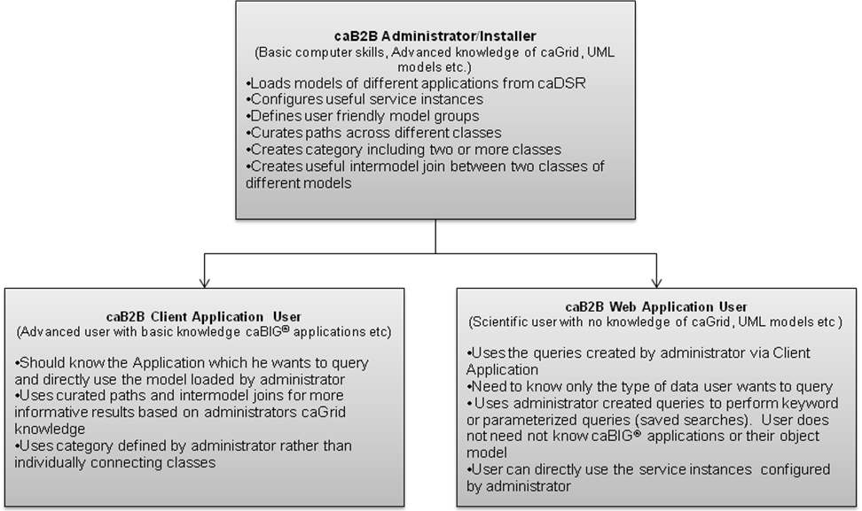
Figure 1.1 High-level overview of caB2B Application

To access the Administrative Module, go to the application URL as mentioned in the caB2B Installation Guide. The system navigates to the Login Page of the Administrative Module, as shown below in Figure 1.1.

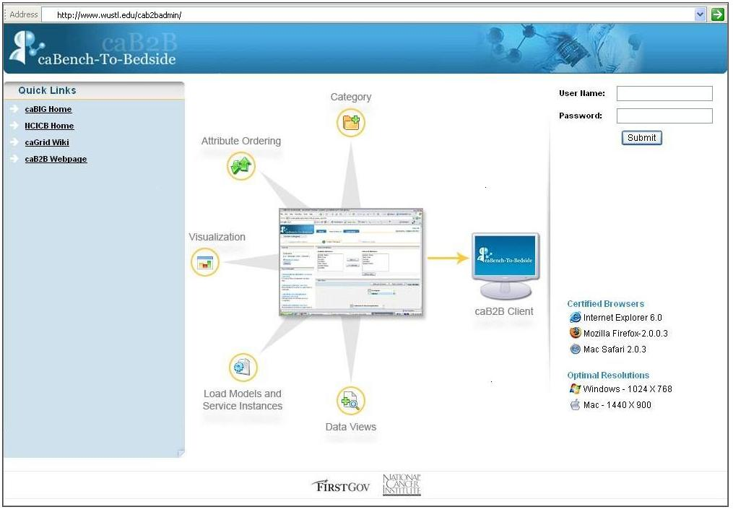
Figure 1.2. caB2B Administrative Module Login Page
You require a valid User Name and Password to log into the Administrative Module. Refer to the Installation Guide for the default admin username and password. Once you log into the Administrative Module, you see the Administrative Module’s Home Page shown below in Figure 1.2.

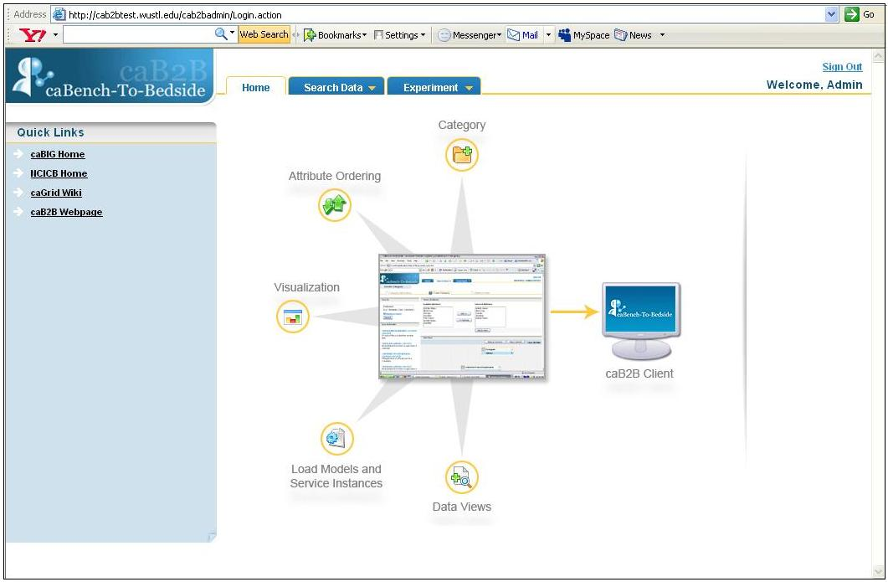
Figure 1.3. caB2B Administrative Module Home Page
The following chapters describe how an Administrator can use the Administrative Module to configure the caB2B Client Application and Web Application.

Document Text Conventions
The following table illustrates documentation conventions represented in this manual.

Convention | Description | Example
 | Indicates information of particular interest
  Administrator can create a new category.
CAUTION | Indicates that you should be particularly aware of the information provided. | CAUTION  Categories once created cannot be modified

Load Models
This chapter describes details of how to load models using the caB2B Administrative Module.
This chapter contains the following topics:
- Introduction
- Loading Models
- Using Loaded Models

Introduction
The Load Models functionality is used to load models from the cancer Data Standards Repository (caDSR) into caB2B Metadata Repository (MDR). The caDSR is the central repository where all the models for the various caGrid-enabled services are stored.
The Load Models functionality fetches all the models available in the caDSR and lets you select and load a model into the caB2B MDR. Once you load a model into the caB2B MDR, the end-users can query the model through the caB2B Client Application. For example, loading the caArray model will enable end user to use caB2B Client Application to query on caArray classes. These classes can be sample, experiment etc with attributes like experiment title and sample name.

What is a Model?
A model here refers to a Domain Model (also known as a UML Model). A domain model is a conceptual model of a system that describes the various entities involved in that system and the relationships between them.
The domain model documents the key concepts and the vocabulary of the system. The model identifies the relationships among all major entities within the system and usually identifies their important methods and attributes. Thus, a model consists of the metadata, which helps to retrieve the information stored in that model. For example, the domain model for caTissue service will have metadata regarding the categories like participant with attributes like first name, last name, gender etc.

What is Metadata Repository?
The Metadata Repository (MDR) stores the metadata for a model including its semantic annotations, such as all Common Data Elements (CDEs) including permissible values by decomposing the annotated UML model obtained from caDSR.
The MDR also contains all possible paths between each pair of entities. The caB2B server pre-calculates the paths between all pairs of entities in the UML model and stores them in the MDR. Classes from different applications are connected based on their attribute’s CDE match. This involves matching the concept codes of the classes and their attributes in order. Finally, given the amount of information it stores, it is also possible to get all the paths between two classes across two different UML models based on semantic interoperability.

Loading Models
To load models, log on into the Administrative Module and then follow the steps given below:
- On the Search Data menu, click Load Models.

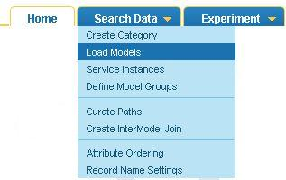
Figure 2.4. Search Data menu
- The Load Model page opens, showing all available models in the caDSR, which have not been loaded in the caB2B MDR yet.

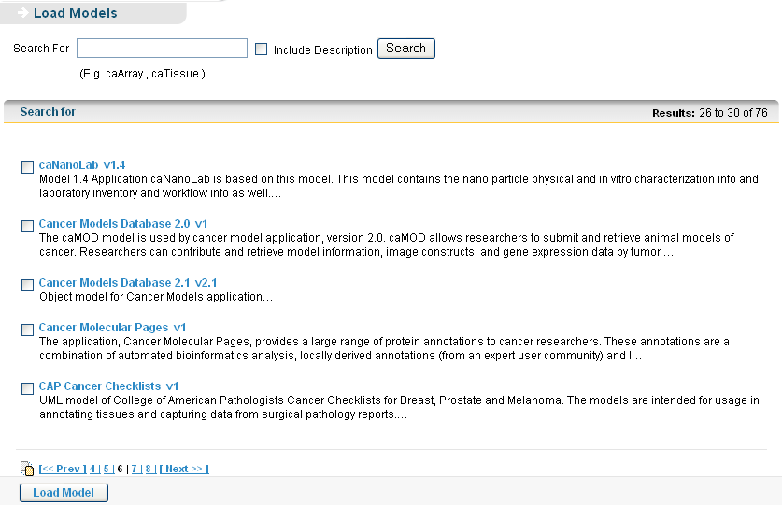
Figure 2.5. Load Models Page
Models once loaded successfully in the MDR are not visible in the available models list on the Load Models page. The same models with different versions are displayed,

- In the Search Box, enter a search string to search for desired model and click Search. Select the Include Description check box if the search string is present in the model description.

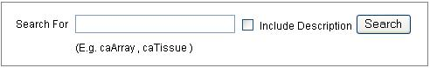
Figure 2.6. Search for Models
- In the search result, select the desired model and click Load Model to start loading the model.
To navigate back to view all matching models in the search result, click Show All Models.

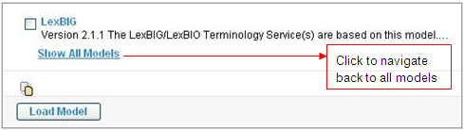
Figure 2.7. Click Load Model to load a model
The user cannot delete or remove a loaded model.

- While the models are loaded, a progress page is displayed.

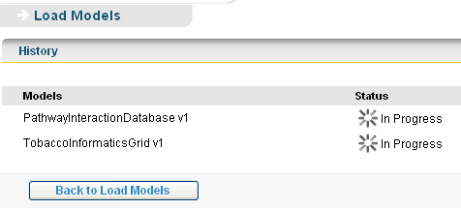
Figure 2.8. Model loading in progress
- The Load Model History page is loaded when model starts loading into the system.
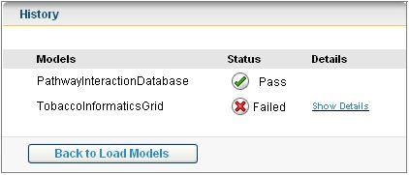
Figure 2.9. Load Model History
If a model fails while loading, then the reason for failure can be viewed by clicking the Show Details link.

While loading models it is possible to select all the models at once and load them all together. Model loading generally fails when the model is not properly annotated or there are some missing links in the model design and not all the paths can be generated while storing the model in the MDR.

Using Loaded Models

Administrator will load the models, which the users of caB2B Client Application and caB2B Web Application want to use. Once the administrator loads the models, the metadata for the model is available for query.
The end user can view the models loaded, by clicking the My Settings link on the home page of caB2B Client Application (refer to caB2B Client Application End User manual).

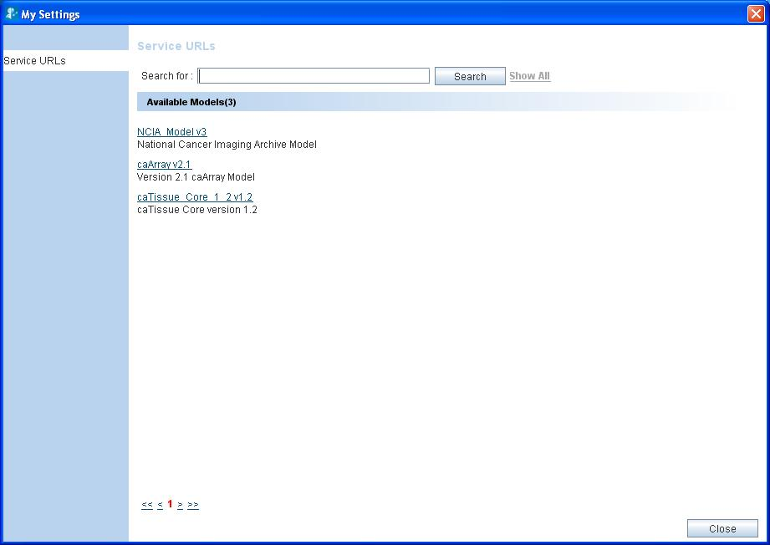
Loaded Model

Figure 2.10. My Settings window showing the available models

The user of caB2B web application will not see the models but they will see the model groups (refer to Define Model Groups) created for the models. These model groups are visible in the What type of data do you wish to search for? dropdown in the caB2B Web Application.

Define Model Groups
This chapter describes about how to use caB2B Administrative Module to define model groups for the different domain models.

This chapter contains the following topics:
- Introduction
- Define Model groups
- Using Model group

Introduction

A Model Group represents one or more UML models that hold similar kind of data. It is a user-friendly representation of the UML models. They are meant to avoid complexity of UML models like their specific names, different versions etc from end user. caB2B administrator can define Model Groups for any of the models loaded using load model (refer to Chapter 2 Load Models) functionality. These models groups are shown to web application user on home page (Refer to caB2B Web Application Manual).
When a particular UML model represents secure data i.e. the data is accessible only to caGrid-authenticated users, then any model group created using such model needs to be a secure model group. For example, administrator can define a model group “Biospecimen data” for caTissue core model. Here the name “Biospecimen data” defines that the model consists of Biospecimen data whereas this is not clear with the name “caTissue”. Therefore, model group creation would help the end user to query the desired data irrespective of UML model or data service knowledge.

Define Model groups
The steps to define a model group are as follows:
- In the Search data menu, click Define Model groups.
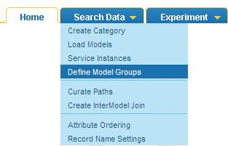
Figure 3.11. Define model group
- Enter the Model Group Name and Description of model group
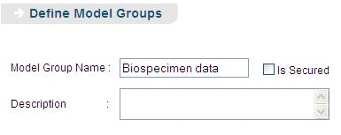
Figure 3.12. Enter the name of model group
- Select Is Secured checkbox, if you are creating a model group for a secure data service i.e. accessible only to caGrid-authenticated users (like, caTissue core model), see Figure 3.12.
- Select the one or more models for which you wish to create the model group from the list of models.
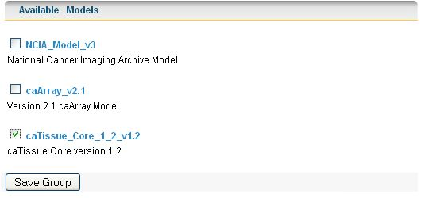
Figure 3.13. Select model from list
- Click Save Group to save the model group.
Figure 3.14. Save Model group
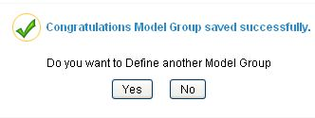
Figure 3.15. Model group saved successfully
- Click Yes if you want to save another model group (refer figure above).
- Click No if you do not want to save another model group (refer figure above).
Select is secured if the data for that service is not publically available

Using Model group
Users of caB2B Web Application use model groups. Once administrator creates the model group, the user can select the model group (type of data from What type of data you wish to search for? drop down in Web Application) and execute a query to fetch results without getting into the complexities of the UML models.
The user does not need to know about UML model or data service, he can just select the type of data (Biospecimen data, Microarray data etc.) and execute a query.
If administrator has marked, the model group as “Is Secured”, then user has to sign in before querying.
For example, if administrator creates a model group as Microarray data for caArray then user can select “Microarray data” from What type of data you wish to search for? and execute a query. When the user selects Microarray data in caB2B Web Application, s/he actually selects the caArray data service. The user executes the queries on the caArray data service.
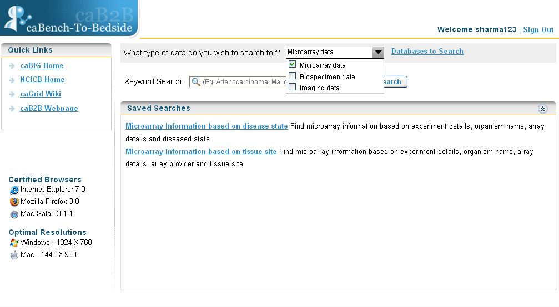
Figure 3.16. Select Model group in caB2B Web Application

Service Instances
This chapter describes the details of how to use the caB2B Administrative Module to configure the service instances.
This chapter contains the following topics:
- Introduction to the Service Instances
- Configuring the Service Instances
- Using Service Instances

Introduction to the Service Instances
Service instances are active caGrid data services of any domain model (For example, caTissue, caArray). A service instance has the metadata same as the corresponding domain model stored in caB2B MDR. You can consider a domain model as a template or guideline for the data and the corresponding service instance(s) as container(s) of the data. When an end-user queries a domain model, the corresponding service instance(s) is queried and the data is fetched from the service instance(s).
The Service Instances functionality finds all the service instances available at a given point of time, for any preloaded domain models. You can select multiple service instances to query for a model. For example, administrator can configure the application to save the Washu caTissue instance and the UPitt caTissue instance to be queried from the caB2B Client Application and caB2B Web Application. When an end-user queries a model from the caB2B Client Application or caB2B Web Application, the data would be fetched from all the instances specified/configured by the administrator.
It is important to define service instances, because if not configured the data cannot be fetched, hence the query cannot be processed.

Configuring the Service Instances
To configure the service instance to be used, first you must log into the Administrative Module and load at least one model.
After you have loaded model(s), follow the steps given below:
- On the Search Data menu, click Service Instances.

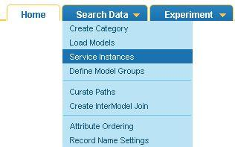
Figure 4.17. Search Data menu
- The Service Instances page appears, showing all loaded models available in the MDR.

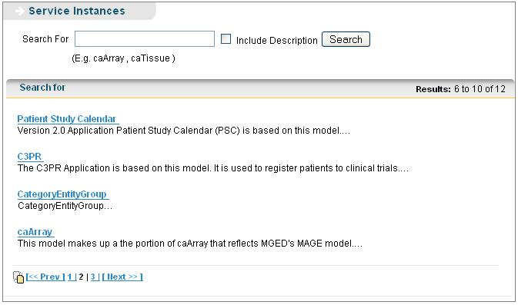
Figure 4.18. Service Instances Page
- In the Search For box, enter a search string to search for desired model and click Search. Select the Include Description check box, if the search string is present in the model description.

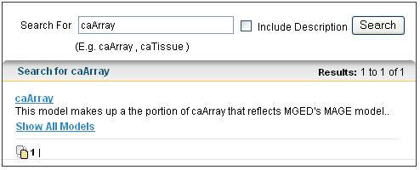
Figure 4.19. Searching a model
- In the search result, click a model name to see all available service instances of that model. Service instance, which are already configured, are shown as checked.
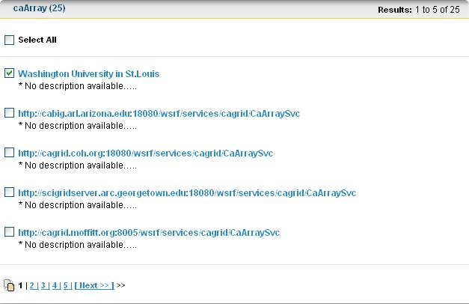
Figure 4.20. Service Instances currently available for the model
Click Back to navigate back to the Service Instances page without saving any of the instances

- Select the corresponding check box to select a service instance and click Save Settings.
- If the instance is saved successfully, a success message window is displayed. Click Yes in the message window to save another service instance, or click No to exit. 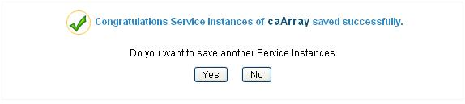
Figure 4.21. Success Message

- If the instance is not saved successfully, a failure message window is displayed.
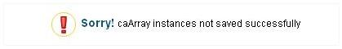
Figure 4.22. Failure message
- User can remove an instance by deselecting the instance and clicking on Save Settings.

Using Service Instances
Service instances are hosted by actual research centers that have data that a user can query. Administrator can configure the service instances that can be queried. By default, a user of the application will be using the administrator-defined settings.
User can change the settings from the My Settings link on caB2B Client Application home page or during the third step of query (refer to caB2B Client Application End User manual )
The administrator-defined service instances are shown selected in caB2B Client Application.

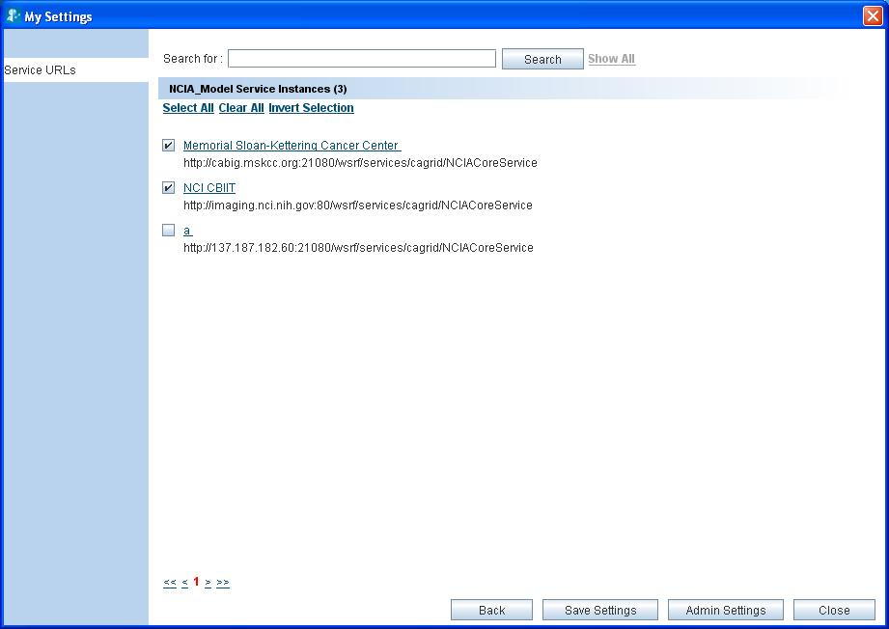
Figure 4.23. Admin defined service instances

In caB2B Web Application, the service instances are available in Databases to Search. Users can view the administrator defined service instances and configure the settings by clicking Databases to Search on home page.
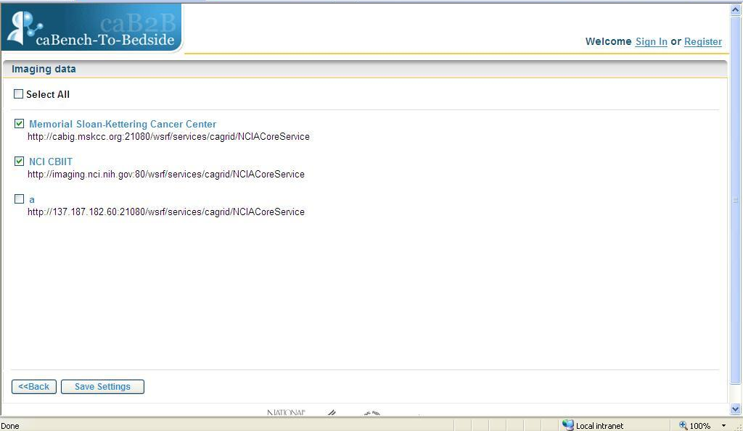
Figure 4.24. Administrator-defined Service instances in caB2B Web Application

Create Category
This chapter describes the details of how to use the caB2B Administrative Module to create categories.
This chapter contains the following topics:
- What is a Category?
- What is a Path?
- How to create a Category?
- Use of Category

What is a Category?
A category is a collection of searchable attributes from different classes. You can use a category to search, view, and add data to experiments from Client Application of caB2B. A category can be a combination of several entities or domain objects or classes.
For example:
- Participant, a domain object in the caTissue Core application, is a class consisting of the following attributes:
- Identifier
- First Name
- Last Name
- Gender
- Race
- Gene Annotation, a domain object in the GeneConnect application, is a class consisting of the following attributes:
- Entrez Gene ID
- Gene Symbol
- Gene Name
- GenBank Accession Number
- Taxonomy ID
- Chromosome
The classes Participant and Gene Annotation in the examples above refer to a single class respectively. You can use the Administrative Module to define categories that refer to more than one entity. You can combine two or more entities, like participant and specimen, to create a category. This category can be customized to have only those attributes from each entity that are generally used in queries.
For example, an end-user wants to query for all the participants whose specimens are available. Since specimen availability is not an attribute of the Participant class, you can create a category, in which the specimen availability attribute from the Specimen class is combined with the attributes from the Participant class. Now the end-user can query a single category with all the desired attributes.
This way, you can have many categories with all the desired attributes from different entities combined together to form a single category.

What is a Path?
A path tells the system how two categories are to be connected. A path is one of the multiple ways in which one category can be connected to another. Since there can be multiple paths connecting two classes, the results of a query will differ based on the path you select. Therefore, it is important to choose the right path for your query.
For example, consider the two categories Specimen and Site (from the caTissue Core application). A Specimen is associated with the Site class in two ways:
- Site where the specimen was collected
- Site where the specimen is stored
That is, there are two paths between the class Specimen and Site: 1) Through Specimen Collection Group for the collection site, 2) Through Storage Container
Query example 1: Show all the available specimens collected in Barnes Jewish Hospital. Since you are specifically interested in a particular collection site in this query, you must choose the path through Specimen Collection Group.
Query example 2: Show all the available specimens stored in Barnes Jewish Hospital. Since you are specifically interested in a particular storage site in this query, you must choose the path through Storage Container.

What is an Ambiguity Resolver?
There are certain classes between which multiple paths exist. These paths provide the end-user with the option of connectivity between the classes via different routes. Depending on the situation, the end-user may wish to choose different paths. In such a situation where multiple paths exist, the end-user is shown an Ambiguity Resolver window when the end-user tries to connect the two categories though the Manual Connect option. Then the end-user can select one of the available paths from the Ambiguity Resolver window to connect the two classes.
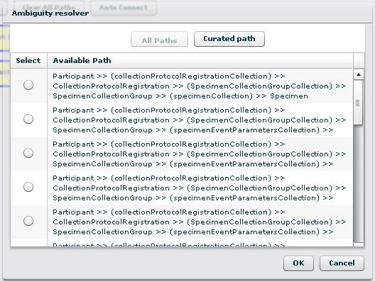
Figure 5.25. Ambiguity Resolver window

How to create a Category?
To create a category, start with logging into the Administrative Module and then follow the steps given below:
- On the Search Data menu, click Create Category.
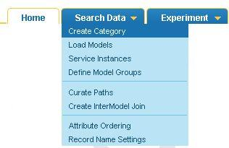
Figure 5.26. Search Data menu
- The Create Category page appears, showing three tabs: Category Information, Create Category, and Attribute Order.
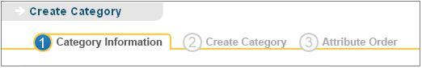
Figure 5.27. Category Creation process
- In the Category Information tab, enter a category title in the Category Title box. Enter the category description in the Category Description box.
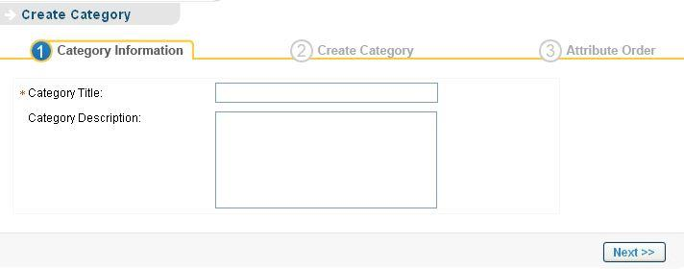
Figure 5.28. Category Information tab
- In the Create Category tab, perform the following steps:
- Enter a search string in the search box and click Search.
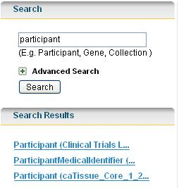
Figure 5.29. Searching for metadata
- In the Search Results area, click the class name to be added to the category. The attributes of the selected class are seen in Available Attributes list.
- In the Available Attributes list, select the attributes to be present in the category (To select multiple attributes, hold down the CTRL key while selecting the attributes).
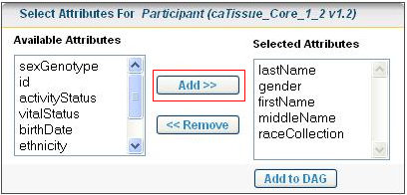
Figure 5.30. The Entity Panel
- Click Add to move the attributes to Selected Attributes list.
In the Selected Attributes list, select the attributes to remove from the category. Click Remove to remove the attributes from the Selected Attributes list.

- Click Add to DAG to add the category to DiAGrammatic View.

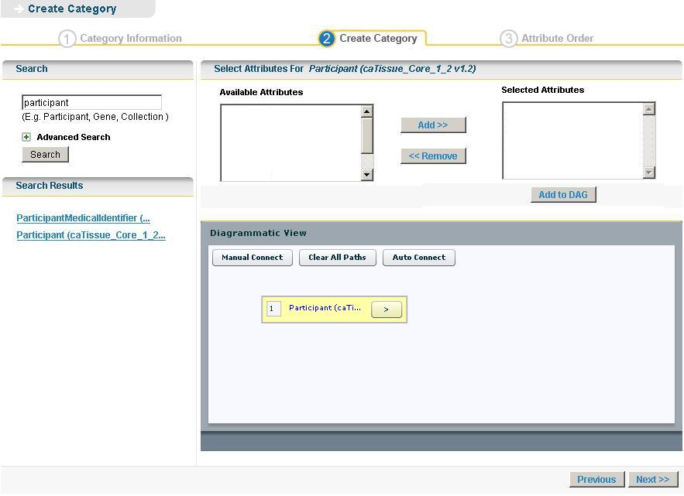
Figure 5.31. The DAG Panel
The DiAGrammatic View (DAG) panel is similar to a canvas where all the classes appear in the form of nodes. The system adds a yellow rectangle or node that represents the class being added to the DAG view. As you continue to add classes, the system adds corresponding rectangles to the DAG view.

- Repeat the steps a to e to add all required classes.
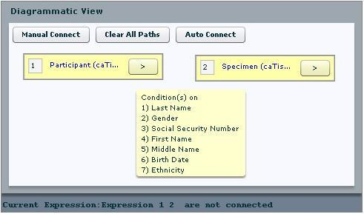
Figure 5.32. Diagrammatic View
Clicking the arrow gives options to edit the conditions or delete the class added to DAG.

- Click Manual Connect to connect the classes. If multiple paths exist between the categories, then Ambiguity Resolver window is displayed. In the Ambiguity Resolver window (see Figure 5.25), select the path.
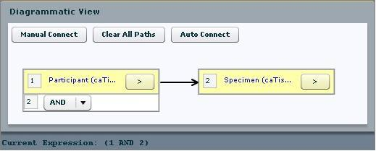
Figure 5.33. DAG with nodes connected
Click Auto Connect to connect the classes when there exists curated paths(see Use of the Curated Path)

- Once all classes are connected, click Next to navigate to the Attribute Order tab.
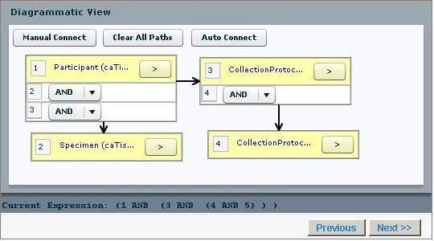
Figure 5.34. Four nodes connected in DAG
- The ordered list of attributes is displayed on Attribute Order tab, where display label can be changed if required. Click Finish to save the category.

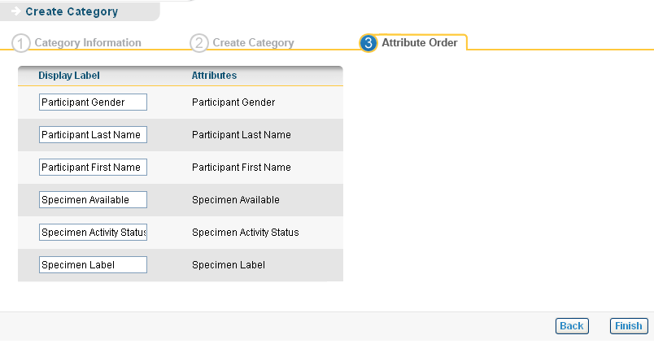
Figure 5.35. Attribute Order tab
- If the category is created successfully, a success message window is displayed. Click Yes in the message window to create a new category, or click No to exit.
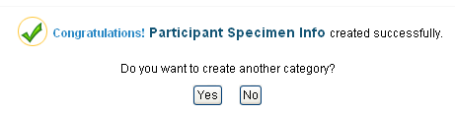
Figure 5.36. Success Message
- An error message is displayed if the category is not saved successfully.

Figure 5.37. Failure Message

Advanced Search
Expanding the Advanced Search box displays the advanced options that help you refine the category search. The following is the default selection of the various options:

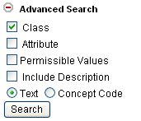
Figure 5.38. Advanced search
If the system returns too many results for your class search, you can use the Advanced Search to narrow your search. The Advance Search options are explained below:
Option | Description
Check Boxes
Class | Includes the class names in the search.
Attribute | Attribute (also known as data element) is the lowest unit of the searchable items. A class contains many attributes.  Select this check box to include the individual attribute names in the search.  For example, If you select the attribute check box and enter search string gender, the search result will include the category Participant since it contains an attribute by name Gender.
Permissible Values | Some attributes contain a fixed set of values. For example, Gender can be Male, Female or Unspecified. Organ can be heart, lung, breast etc.  This fixed set is known as Permissible Values.  Select this check box to include the permissible values in the search.  For example: If you select the Permissible Values check box and enter search string Male, the search result will include the Participant category. The Participant category contains an attribute Gender that contains a permissible value Male gender.
Include Description | Includes the description text in the search.  Note: Include Description check-box will be enabled only for a text-based search when you select the Class check box, the Attribute check box, or both.
Options
Text | The system matches the text that you type as the search string with the name of the class, its attributes, or the permissible values.  This is the default search option and a simple, most commonly used way of searching a category.
Concept Code | The system treats the search string that you type as an Enterprise Vocabulary Services (EVS) concept code. The system matches this concept code with the concept code of the category, its attributes, or the permissible values. The results contain matching categories.  More details in concept code can be found on http://nciterms.nci.nih.gov/NCIBrowser/SearchConcept.do and http://ncimeta.nci.nih.gov/MetaServlet/

Use of Category
Administrator can create category to make the query process easier for the user. If an administrator creates a category consisting of two or more classes from domain model, the end user can search for that category in caB2B Client Application and query all the classes together.
For example, an end user wants to query “All tissue specimens from female participants”. Administrator will a create a category “Tissue specimen details” as explained above
Steps to use category:
- Launch caB2B Client Application.
- Enter the search string as “Tissue specimen details”.
- Click Search
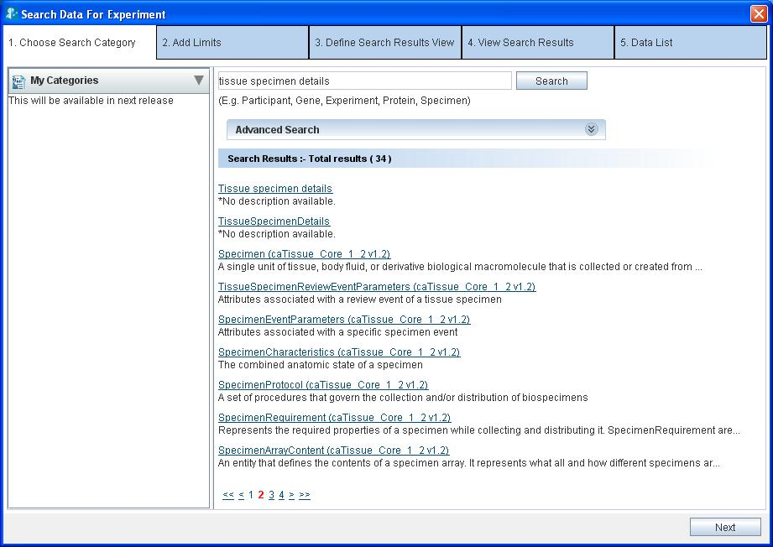
Figure 5.39. Search category in caB2B Client Application

- Click on the category name from the search results obtained and navigate to the Add Limits page.
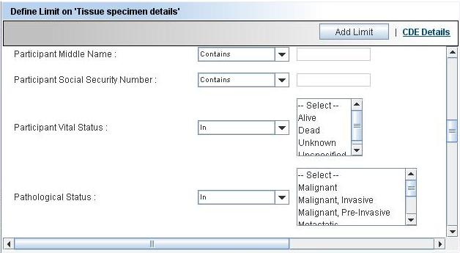
Tissue Specimen Attribute
Participant Attribute
Figure 5.40. Add Limits page for Category
- Enter limit on any of the attributes as all the attribute of both the classes are available in one add limit page.
- Click Add Limit to add the node to DAG.
- Click Next to execute the query (refer caB2B Client Application End User manual to Execute query)

Advantages of category
- Creating a single category saves the time of adding all the classes required for the query.
- User can view the results of all the classes in category together rather than navigating through related data.
- User can add limits on one category in a single add limit page rather than adding to different classes.
- User can add limits and query category without bothering about the path between the classes in a category.

Curate Paths
This chapter describes the details of how to use the caB2B Administrative Module to curate paths.
This chapter contains the following topics:
- Introduction to the Curated Paths
- Creating Curated Paths
- Use of the Curated Path

Introduction to the Curated Paths
You already know that a path is one of the multiple ways in which one class can be connected to another class. There can be multiple ways to connect two classes and it is possible that only a few of these multiple paths available are useful while querying the domain model. As the administrator, you must be able to define the most useful and frequently used paths to be selected by default, which are known as curated paths. These could be the paths, which are selected most of the times while querying. The curated paths reduce the caB2B users’ task of selecting the most suitable and logical path from the available paths.
For example, multiple paths are available to connect the two classes Specimen Collection Group (caTissuecore v1.2.2) and Specimen (caTissuecore v1.2.2). Most of these paths consist of one of the event parameters classes in the path, like fixed event parameter or transfer event parameter. A user may not be interested to know if the specimen has been thawed or if the specimen has been fixed or it has been embedded. Most of the times what the user is interested to know is what kind of specimens are available or those that have been collected and are available for use. For finding such specimens, the user can just query on the Specimen class and connect it directly to the Specimen Collection Group.
As the administrator, you can select one of the available paths that would connect two or more classes and exclude the rest of the paths. This way, the paths between the classes are curated. The curated path is always given a preference over all the other available paths, and is selected by default when connecting classes. If administrator curates more than one path, then the end-user is shown all the curated paths to make a selection.

Creating Curated Paths
You can define a curated path between two or more classes. All the classes used to define a curated path should be from the same domain model.
For example, it is possible to define a path between Participant, Participant Medical Identifier, Collection Protocol Registration, and Collection Protocol categories since they are from the model caTissuecore v1.2.2. However, a curated path cannot be defined between the classes from different models like Gene from caFEv1.1 and Gene from GeneConnect as these are from the different models.
To curate a path, start with logging into the Administrative Module and then follow the steps given below:
- On the Search Data menu, click Curate Paths.

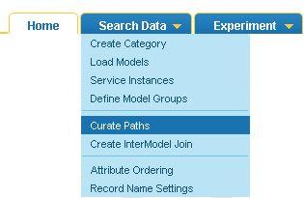
Figure 6.41. Search Data menu
- Enter the search string in the search box.

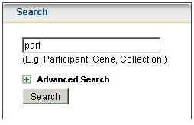
Figure 6.42. Text box to enter the search string
- In the Search Results area, click the category name to add it to the Diagrammatic View. Add two or more classes between which the path is to be curated.
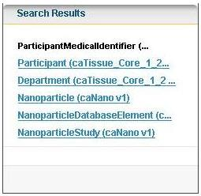
Figure 6.43. Select Class to add in DAG
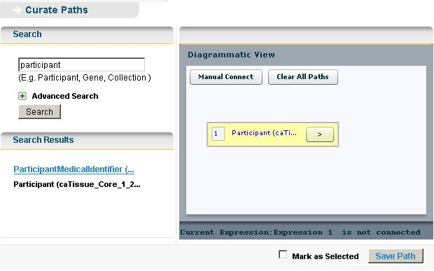
Figure 6.44. The DAG Panel
- In the Diagrammatic View, select a pair of classes and click Manual Connect to define the path between them.
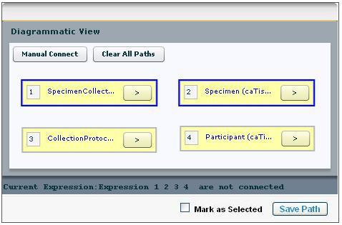
Figure 6.45. Defining path between a pair of classes
- Similarly connect all the classes listed in the Diagrammatic View.

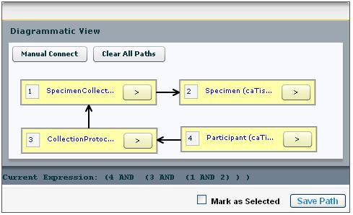
Figure 6.46. All classes connected to form a complete graph
- Select Mark as Selected check box, if you want this path to be chosen by default while querying. Once a path is marked as selected no other paths are shown to the user.
- Click Save Path to curate and save the path present between the categories.
- If the curated path is stored successfully, a success message is displayed. Click OK in the dialog box.
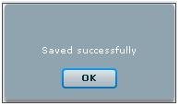
Figure 6.47. Success Message
- If the path already exists, a warning message is displayed and the path is not saved again.

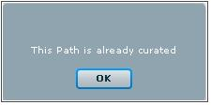
Figure 6.48. Failure Message

Use of the Curated Path
A curated path can be used while querying as well as while defining a category. In both the cases, the same method is used to connect the classes. The steps used are outlined below:
- Using curated path to define category:
- To create categories, refer to the topic “How to create a Category?” up to step 4.g, in the Chapter 5 Create Category.
- Select all the classes between which a path is defined. Then perform step i if there are more than 2 classes in DAG else perform step ii or iii.
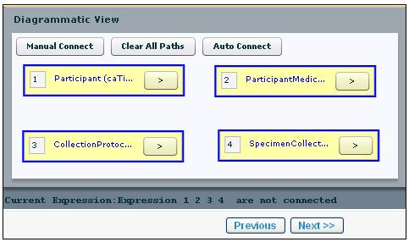
Figure 6.49. Select all nodes
  - Click Auto Connect to connect all the classes with the defined curated path. If multiple curated paths exist, then the Ambiguity Resolver window is displayed to select a single curated path.

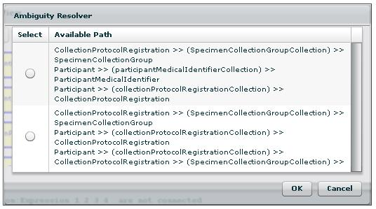
Figure 6.50. Ambiguity Resolver window for multiple curated paths
  - Click Manual Connect, an Ambiguity Resolver window is shown with the curated paths as the default view, select the path and save the category.
Manual connect works when there are only two classes present in the Diagrammatic View.

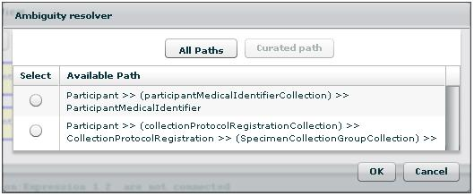
Figure 6.51. Curate path as default view
  - Click All Paths in the Ambiguity Resolver window to select a path other than the curated path and save the category.

- Using curated path while querying:
- While querying the applications in caB2B Client Application, specify the limits (Refer to section Define Limits in caB2B v3.0 Client Application end user manual).
- Select all the classes in DAG and click Auto Connect to connect the classes with the curated path.
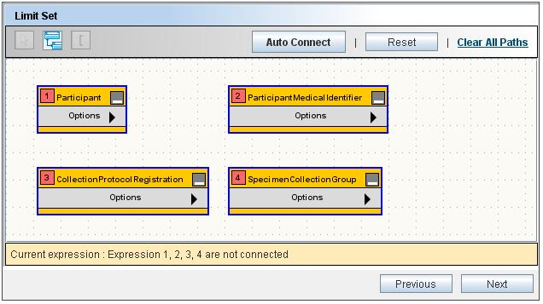
Figure 6.52. Selected nodes in caB2B Client Application
- If the path has been marked as selected by administrator while creating the curated path, then that path is used by default and the classes are connected.
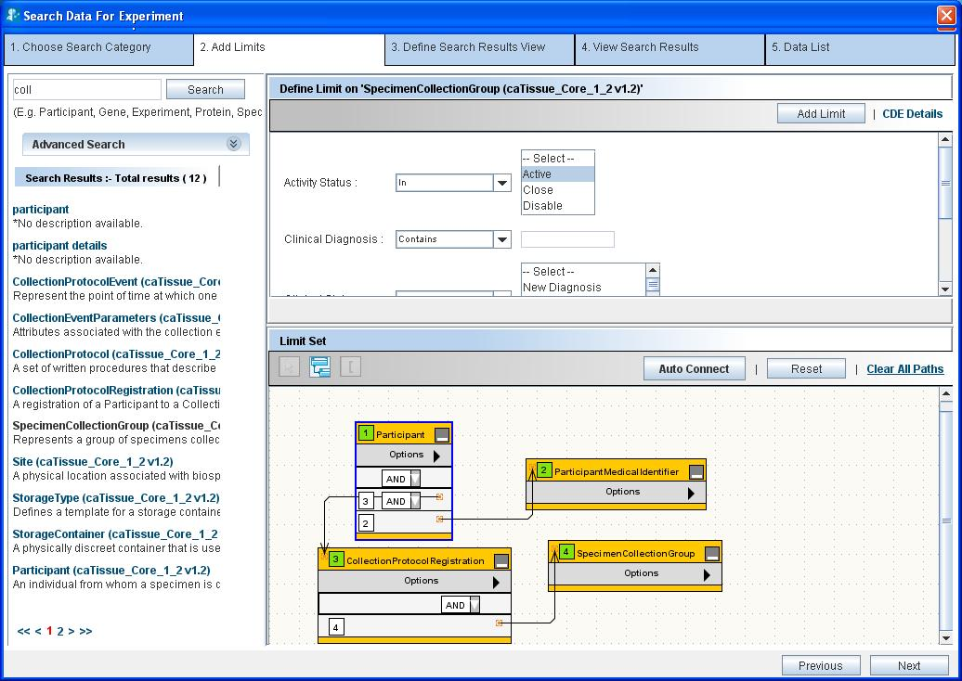
Figure 6.53. Classes connected in DAG during query using curated paths
- If multiple paths exist then an ambiguity resolver window is shown, select the most appropriate path to connect the classes.
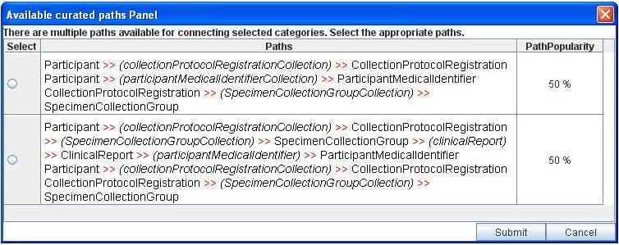
Figure 6.54. Ambiguity resolver for more than one curated paths
- A message is displayed if no curated paths exist.
Thus, a curated path once defined can be used to connect the classes directly, which helps the end-user save time.

Inter Model Joins
This chapter describes the details of how to use the caB2B Administrative Module to create inter model joins.
This chapter contains the following topics:
- Need for Inter Model Joins
- Introduction to Inter Model Joins
- Creating an Inter Model Join
- Using Inter model Join

Need for Inter Model Joins
There are many domain models, which share some common data. However, due to the unavailability of interoperability between the models, it is not possible to get the data from across the models. To connect the different models and share data among them, it is necessary to have a common link between these different models.
For example, a translational scientist collects a sample and stores the sample information in a tissue banking software, such as caTissue. Later he performs a microarray experiment on the sample and stores this experiment data in the caArray repository. In future, when he/she wants to know the details of the specimen used in a microarray experiment, then he/she has to query the caTissue and caArray individually to retrieve the information. If there is a connection defined between caTissue and caArray model based specimen then he/she can directly retrieve the desired information with a single query. This way one can also use common attributes like Gene ID to query between tools like caFE and GeneConnect. To provide this type of inter model compatibility, you need to define inter model joins.

Introduction to Inter Model Joins
Defining an Inter model join is similar to defining a curated path between classes from two different models. This join defines a connection between any two models.
For example, consider two models GeneConnect and caFE. Both of these models have a class called Gene having attributes Id, Symbol, Name, Summary, Pubmed count and chromosome map for caFE gene and Id, EnterzGeneId, EntrezGene as Output, etc. from GeneConnect.
If a user wants to retrieve all the genomic identifiers for a gene, for which the user knows the gene symbol, then he has to query all the databases individually and retrieve, gather and curate information from all the sources. This task can be simplified by defining inter model joins. In an inter model join, two categories are connected based on the common attributes, i.e., if the two classes have some common attributes with same concept codes, then joins are defined on such attributes.
While curating path across two models, the administrator must add the classes, which are the end points of inter-model bridge. The two classes are connected by the public ID of the attributes, which is the same as Data Element public ID as present in the Common Data Element (CDE) browser (http://cdebrowser.nci.nih.gov/CDEBrowser/). The classes can also be connected by matching Data Element Concept (DEC), which includes matching the concept codes of the attributes and the classes as present in the NCI Metathesaurus (http://nciterms.nci.nih.gov/NCIBrowser/Dictionary.do). An administrator can also define the attributes manually which should be used to bridge the two classes.

Creating an Inter Model Join
An inter model join can be defined only between two classes from different models, and it acts like a bridge connecting two separate models. To define an inter model connection, start with logging into the Administrative Module, and then follow the steps given below:
- On the Search Data menu, click Create InterModel Join.

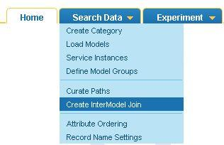
Figure 7.55. Search Data menu
- Enter the search string in the search box.
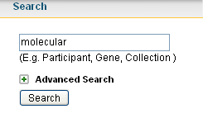
Figure 7.56. Search box
- In the Search Results area click on the class name, that is to be added in the DAG.
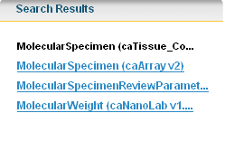
Figure 7.57. Search results
- The class appears in the DAG. Add the second class to the DAG.
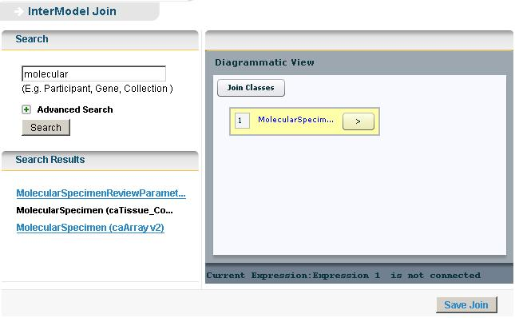
Figure 7.58. DAG Panel
- Select both the classes and then click on Join Classes.
- From the pop-up window, select one of the many paths.
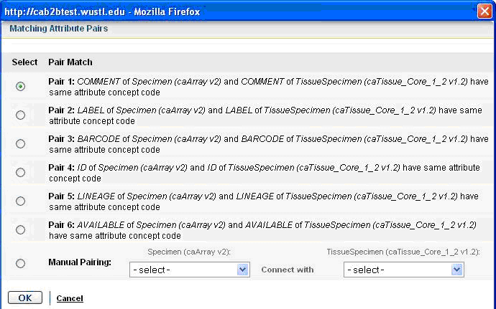
Figure 7.59. Pop-up window displaying the paths
- If no paths are available or to override the available paths select the attributes to be connected manually, by selecting attributes from the option Manual Pairing.
- Click OK to save the selected path.
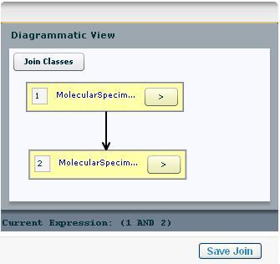
Figure 7.60. Classes connected in DAG
- Once the nodes are connected, click Save Path to save the inter model connection.
- If the inter model join is saved successfully, a success message is displayed.
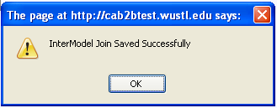
Figure 7.61. Success Message
- If a duplicate inter model join is defined, then an error message is displayed.
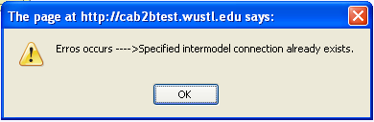
Figure 7.62. Failure Message

Using Inter model Join
These inter model connections once defined can be used while creating categories or while querying the caB2B Client Application (refer to Use of the Curated Path). This path can be used to query across the models by connecting two classes from different models.
Example: if administrator creates an inter model join between gene (caFE) and gene (Geneconnect), then this path can be used for querying. The two classes are joined through the defined path.
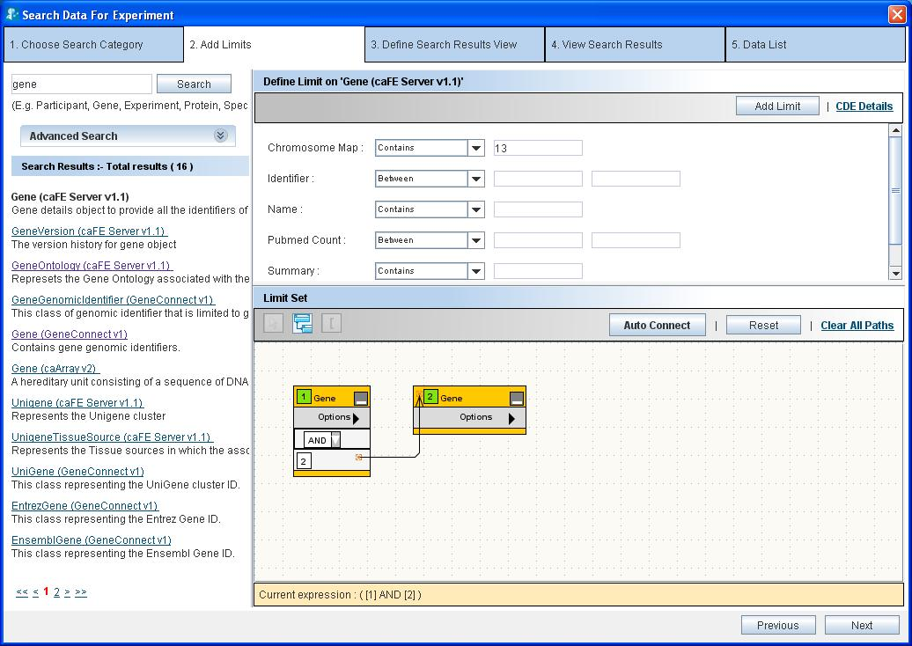
Figure 7.63. Classes connected in DAG as per the inter model joins defined

Index

administrator 3
Advanced Search See Search
Ambiguity Resolver 26, 27, 31, 42, 43
attributes 9, 25, 26, 29, 32, 33, 34, 47, 50
Auto Connect 42, 43
caB2B 1, 3, 4, 5, 6, 9, 10, 19, 25, 37, 43, 47, 51
caDSR 3, 9, 10
caFE 47
caGrid 3
cancer Data Standards Repository See caDSR
categories See category
caTissuecore v1.2.2 37
classes 9, 30, 37, 39, 41, 42, 43, 44, 45, 46, 47, 48, 49
Collection Protocol categories 37
Collection Protocol Registration 37
Common Data Element See CDE
Common Data Elements See CDE
configure the service instance 19
Creating Experiments 19
Curate 1, 4, 5, 37, 38
Curate Paths 37
Data Element public ID 47
DiAGrammatic View See DAG
Enterprise Vocabulary Services See EVS
entities See categories
EVS 34
Experiments
creating 19
GeneConnect 47
Home Page 7
Installation Guide 7
instances See service instances
inter model join 47
Join Classes 49
joins See Inter Model Joins
Login 3, 6
Login Page 6
Manual Connect 26, 31, 39, 42
Manual Pairing 50
MDR 9, 10, 11, 20
Metadata Repository See MDR
methods 9
model 3, 4, 5, 9, 11, 13, 19, 20, 21, 37, 47, 48, 51
Participant 25, 33, 34, 37
Participant Medical Identifier 37
Password 7
Path 5, 25, 26, 37, 40, 41, 51
Permissible Values 34
Projects 19
query 3
Query Wizard 9
Search categories 26
searchable 25
service instances 4, 19, 21
Specimen 26, 37
Specimen Collection Group 37
UML Model See Domain Model
User Name 7

